**1)package** project1;

**public** **class** welcome {

**public** **static** **void** main(String[] args) {

System.***out***.println("welcome world");

}

}

welcome world

**2)package** project1;

**public** **class** Floatnumber {

**public** **static** **void** main(String[] args) {

**float** a= 22.5f;

**float** b= 10.22f;

**float** c=25.36f;

**float** d =a+b+c;

System.***out***.println(d);

}

}

58.08

**3)package** project1;

**public** **class** swapnumber {

**public** **static** **void** main(String[] args) {

**int** a = 50;

**int** b = 100;

**int** temp;

temp =a;

a =b;

b =temp;

System.***out***.println("after swapping " + a + " " + b);

}

}

after swapping 100 50

**4)package** project1;

**public** **class** evenodd {

**public** **static** **void** main(String[] args) {

**int** a = 20 ;

**if**(a%2==0)

System.***out***.println("number is even");

**else**

System.***out***.println("number is odd");

}

}

number is even

**5)package** project1;

**public** **class** threegivennumber {

**public** **static** **void** main(String[] args) {

**int** a= 60;

**int** b = 50;

**int** c = 100;

**if**(a>20 && a<b && a<c )

{

System.***out***.println("condition is true");

}

**else**

System.***out***.println("condition is false");

}

}

condition is false

**6)package** project1;

**public** **class** voting {

**public** **static** **void** main(String[] args) {

**int** a = 18;

**int** b = 101;

**if** (a>= 18 && a<=100)

System.***out***.println("A is Eligible for voting");

**else**

System.***out***.println("Ais not eligible");

**if** (b>= 18 && b<=100)

System.***out***.println("B is Eligible for voting");

**else**

System.***out***.println("B is not eligible");

}

}

A is Eligible for voting

B is not eligible

----------------------------------------------------------------------------------

**7)package** project1;

**public** **class** averagemarks {

**public** **static** **void** main(String[] args) {

**int** maths = 10;

**int** science = 25;

**int** eng = 10;

**int** hindi = 20;

**int** marathi = 10;

**int** avg = (10+25+10+20+10)/5;

**if**(avg>=40)

System.***out***.println("Pass");

**else**

System.***out***.println("Fail");

}

}

Fail

**8)package** project1;

**import** java.util.Scanner;

**public** **class** NameAgeSalary {

**public** **static** **void** main(String[] args) {

String name;

**int** age ;

**int** salary;

Scanner myObj =**new** Scanner(System.***in***);

System.***out***.println("Enter name");

name=myObj.next();

System.***out***.println("Enter age");

age= myObj.nextInt();

System.***out***.println("Enter salary");

salary=myObj.nextInt();

System.***out***.println("My name is" + " " + name +" "+ "My age is"+ " " + age + " " +"My Salary is"+ " " + salary);

}

}

Enter age

25

Enter salary

50000

My name is Samiksha My age is 25 My Salary is 50000

**9)package** project1;

**import** java.util.Scanner;

**public** **class** Greaternumber {

**public** **static** **void** main(String[] args) {

**int** num1;

**int** num2;

Scanner s = **new** Scanner(System.***in***);

System.***out***.println("Enter num1");

num1=s.nextInt();

System.***out***.println("Enter num2");

num2=s.nextInt();

**if**(num1>num2)

System.***out***.println("num1 is greater");

**else**

System.***out***.println("num2 is greater");

}

}

Enter num1

25

Enter num2

75

num2 is greater

**10)package** project1;

**import** java.util.Scanner;

**public** **class** Productname {

**public** **static** **void** main(String[] args) {

String name;

**int** price;

**int** discount;

Scanner myObj=**new** Scanner(System.***in***);

System.***out***.println("Enter product name");

name=myObj.next();

System.***out***.println("Enter product price");

price=myObj.nextInt();

**if**(price>2000)

{

discount=(price*10)/100;

System.***out***.println("My discount is"+ discount);

}

**else**

{

discount=(7/100)*price;

System.***out***.println("My discount is "+ discount);

}

}

}

Enter product name

AntivirusSoftware

Enter product price

5000

My discount is500

**11)package** project1;

**import** java.util.Scanner;

**public** **class** Bonus {

**public** **static** **void** main(String[] args) {

**int** sale;

**float** bonus;

Scanner s = **new** Scanner(System.***in***);

System.***out***.println("Enter sale of person");

sale=s.nextInt();

**if**(sale>10000)

{

System.***out***.println("Person is eligible for bonus");

bonus=(sale*20)/100;

System.***out***.println("Bonus amount" + " "+ bonus);

}

**else**

System.***out***.println("Person is not eligible for bonus");

}

}

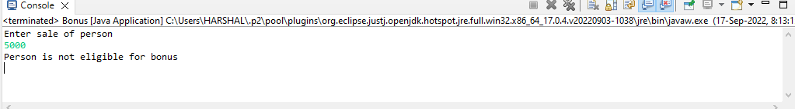

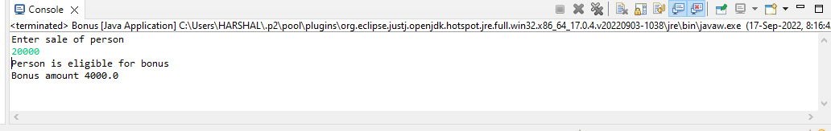-----------------------------------------------------------------------

**package** project2;

**public** **class** sumofintergers {

**public** **static** **void** main(String[] args)

{

**int** count=0;

**int** sum=0;

**for**(**int** i=101;i<200;i++)

{

**if**(i%7==0)

{

sum=sum+i;

}

}

System.***out***.println("My sum is"+ " "+ + sum);

}

}

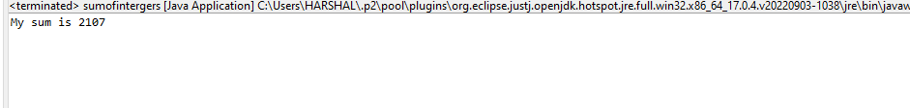

**package** project2;

**import** java.util.Scanner;

**public** **class** asciivalue {

**public** **static** **void** main(String[] args) {

**char** x;

Scanner s=**new** Scanner(System.***in***);

System.***out***.println("enter any character");

x=s.next().charAt(0);

**int** ascii=x;

System.***out***.println("ascii value of character :"+ " "+ ascii);

}

}



**package** project2;

**import** java.util.Scanner;

**public** **class** greatestnum {

**public** **static** **void** main(String[] args) {

**int** num1;

**int** num2;

**int** num3;

Scanner s = **new** Scanner(System.***in***);

System.***out***.println("Enter num1");

num1=s.nextInt();

System.***out***.println("Enter num2");

num2=s.nextInt();

System.***out***.println("Enter num3");

num3=s.nextInt();

**if**(num1>num2 && num1>num3)

System.***out***.println("Num1 is greater");

**else** **if**(num2>num1 && num2>num3)

System.***out***.println("Num2 is greater");

**else**

System.***out***.println("Num3 is greater");

}

}

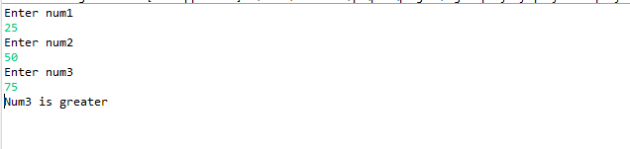

**package** project2;

**import** java.util.Scanner;

**public** **class** vpwelconsonanr {

**public** **static** **void** main(String[] args) {

**char** ch;

Scanner s = **new** Scanner(System.***in***);

System.***out***.println("Enter alphabet:");

ch =s.next().charAt(0);

**if**(ch =='a'||ch=='e'||ch=='i'||ch=='o'||ch=='u')

System.***out***.println("Alphabet is vowel");

**else**

System.***out***.println("Alphabet is consonant");

}

}

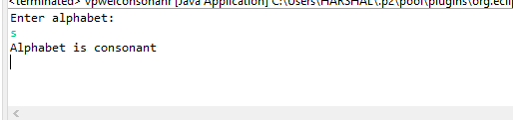

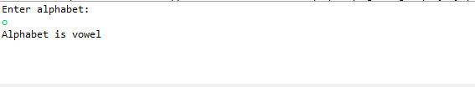

**package** project2;

**import** java.util.Scanner;

**public** **class** postnegtnum {

**public** **static** **void** main(String[] args) {

**int** num;

Scanner s = **new** Scanner (System.***in***);

System.***out***.println("Enter num:");

num = s.nextInt();

**if**(num>0)

System.***out***.println(num + " "+ " is positive");

**else**

System.***out***.println(num + " "+ " is negative");

}

}

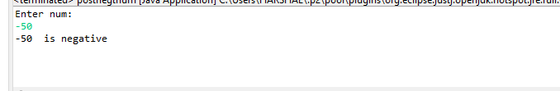

**package** project2;

**import** java.util.Scanner;

**public** **class** swapping {

**public** **static** **void** main(String[] args) {

**int** num1;

**int** num2;

Scanner s = **new** Scanner (System.***in***);

System.***out***.println("Enter num1");

num1 = s.nextInt();

System.***out***.println("Enter num2");

num2 = s.nextInt();

num1=num1+num2;

num2=num1-num2;

num1=num1-num2;

System.***out***.println("After Swapping"+" "+num1+" "+ num2);

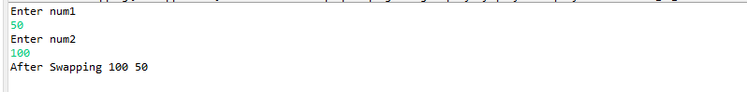

**package** project2;

**public** **class** evennum {

**public** **static** **void** main(String[] args) {

**for**(**int** i=10;i<=20;i++)

{

**if**(i%2==0)

System.***out***.println(i);

}

}

}

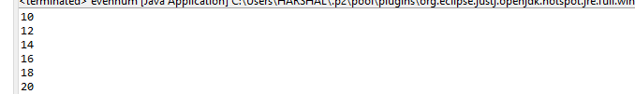

**package** project2;

**public** **class** reversedigit {

**public** **static** **void** main(String[] args) {

**int** num=123;

**int** reverse=0;

**for**( ;num!=0;num/=10)

{

**int** digit = num % 10;

reverse=reverse*10+digit;

}

System.***out***.println("Reverse no"+ " " + reverse);

}

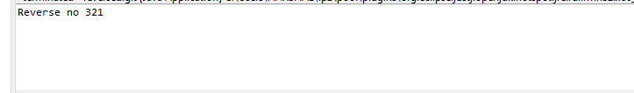

**package** project2;

**import** java.util.Scanner;

**public** **class** primenum {

**public** **static** **void** main(String[] args) {

**int** n;

**int** count =0;

Scanner s = **new** Scanner (System.***in***);

System.***out***.println("Enter value of n");

n = s.nextInt();

**for**(**int** i=1;i<=n;i++)

{

**if**(n%i==0)

{

count++;

}

}

**if**(count==2)

{

System.***out***.println("Number is prime");

}

**else**

{

System.***out***.println("Number is not prime");

}

}

}



